**MODBUS RTU SETUP FOR VACON 100 DRIVES**

**1. Enable Modbus RTU Protocol**  
The RS-485 port must be configured to use the Modbus RTU protocol.

* **Parameter Name:** RS-485 protocol
* **Parameter ID:** 2208
* **Panel Tree Path:** P 5.8.1.1
* **Default Value:** 0 (No Protocol)
* **Required Value:** 1 (Modbus RTU)
* **Keypad Navigation:** From the main screen, press the navigation keys to go to: **Main Menu > Parameters > 5.8.1.1 RS-485 protocol**. Set the value to 1.

**2. Set the Device (Slave) Address**  
Each slave on the network must have a unique address.

* **Parameter Name:** Slave address
* **Parameter ID:** 2320
* **Panel Tree Path:** P 5.8.3.1.1
* **Default Value:** 1
* **Required Value:** 1 (This is the desired value from your request)
* **Keypad Navigation:** Navigate to: **Main Menu > Parameters > 5.8.3.1.1 Slave address**. Confirm the value is 1.

**3. Set the Baud Rate**  
This defines the communication speed for the network.

* **Parameter Name:** Baud rate
* **Parameter ID:** 2378
* **Panel Tree Path:** P 5.8.3.1.2
* **Default Value:** 6 (This corresponds to 9600 baud. See table below.)
* **Required Value:** 6 (for 9600 bps)
* **Keypad Navigation:** Navigate to: **Main Menu > Parameters > 5.8.3.1.2 Baud rate**. Set the value to 6.

*Baud Rate Value Table (from manual):*

|  |  |
| --- | --- |
| Value | Baud Rate |
| 0 | 300 |
| 1 | 600 |
| 2 | 1200 |
| 3 | 2400 |
| 4 | 4800 |
| 5 | 9600 |
| 6 | 19200 |
| 7 | 38400 |
| 8 | 57600 |
| 9 | 76800 |
| 10 | 115200 |
| 11 | 230400 |

Summary of Parameter Changes:

|  |  |  |  |  |
| --- | --- | --- | --- | --- |
| Parameter Name | ID | Path | Default Value | Required Value |
| RS-485 protocol | 2208 | P 5.8.1.1 | 0 (No Protocol) | 1 (Modbus RTU) |
| Slave address | 2320 | P 5.8.3.1.1 | 1 | 1 |
| Baud rate | 2378 | P 5.8.3.1.2 | 6 (9600 bps) | 6 (9600 bps) |
| Parity type | 2379 | P 5.8.3.1.3 | 0 (Even) | 2 (None) |
| Stop bits | 2380 | P 5.8.3.1.4 | 3 (2 stop bits) | 1 (1 stop bit) |

**4. Built-in Termination Resistor**

**Vacon 100 drive has a built-in termination resistor that can be enabled or disabled via a DIP switch.**

* **Location:** The DIP switches are located to the right of the control keypad on the main unit. On the Vacon 100 X model, they are on the top of the control unit.
* **Switch:** The specific switch for the **RS-485 bus termination resistor** must be set to **ON**.
* **Important Note:** The manual states that **"Biasing is built in the termination resistor."** This means when you enable the termination resistor using the DIP switch, the necessary bus biasing (pulling the line to a defined '1' state when idle) is also included.
* **When to Use:** This termination should only be activated for the **first and last device** on the Modbus RTU network chain.

**RS485 WIRING**

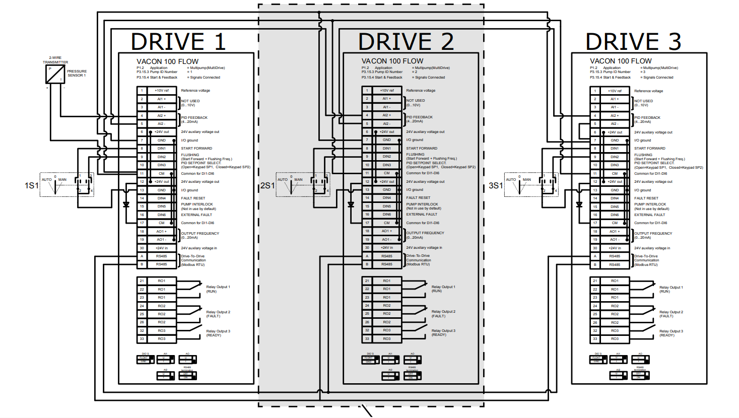RS485-A and RS485-B manual didn’t suggest external terminating resistor it has ha switch for terminating resistor

**TERMINATION WIRING AND TERMINATING DIP SWITCH**

